Project Planning Phase Prepare Milestone & Activity List

|  |  |
| --- | --- |
| Date | 27 October 2022 |
| Project Name | Smart Farmer - IoT Enabled Smart Farming  Application |
| Maximum marks | 4 Marks |
| TEAM ID | PNT2022TMID15139 |

**PROJECT TIMELINE:**

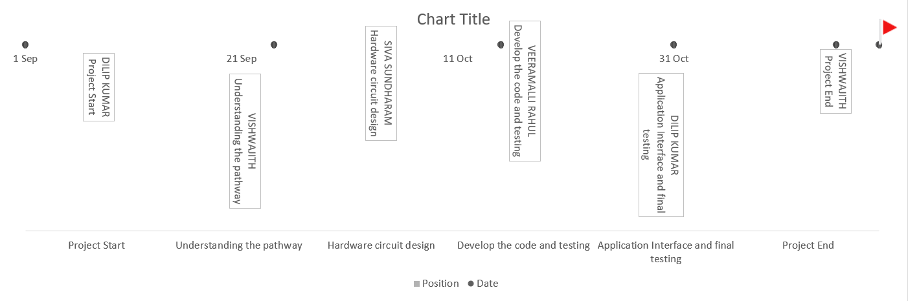

**PROJECT MILESTONE:**

|  |  |  |  |
| --- | --- | --- | --- |
| Date | Milestone | Assigned To | Position |
| 01-09-2022 | Project Start | DILIP KUMAR | TEAM LEADER |
| 24-09-2022 | Understanding the pathway | VISHWAJITH | TEAM MEMBER |
| 15-10-2022 | Hardware circuit design | SIVA SUNDHARAM | TEAM MEMBER |
| 31-10-2022 | Develop the code and testing | VEERAMALLI RAHUL | TEAM MEMBER |
| 15-11-2022 | Application Interface and final testing | DILIP KUMAR | TEAM LEADER |
| 19-11-2022 | Project End | VISHWAJITH | TEAM MEMBER |

|  |  |  |  |
| --- | --- | --- | --- |
| **S.NO** | **ACTIVITY TITLE** | **ACTIVITY DESCRIPTION** | **DURATION** |
| 1 | **Understanding the project** | Assign the team members after that create repository in the GitHub and then assign task to each member and guide them how to access the GitHub while submitting the  Assignments. | 1 week |
| 2 | **Staring The Project** | Team Members to Assign All the Tasks Based on Sprints and  Work on It Accordingly. | 1 week |
| 3 | **Completing Every Task** | Team Leader should ensure that whether every team member  have completed the assigned task or not. | 1 week |
| 4 | **Stand Up Meetings** | Team Lead Must Have a Stand-Up Meeting with The Team and Work on The Updates and Requirement  Session. | 1 week |

|  |  |  |  |
| --- | --- | --- | --- |
| 5 | **Deadline** | Ensure that team members are completing every task within the deadline. | 1 week |
| 6 | **Budget and Scope of project** | Analyze the overall budget which must be within certain limit it  should be favorable to every person. | 1 week |